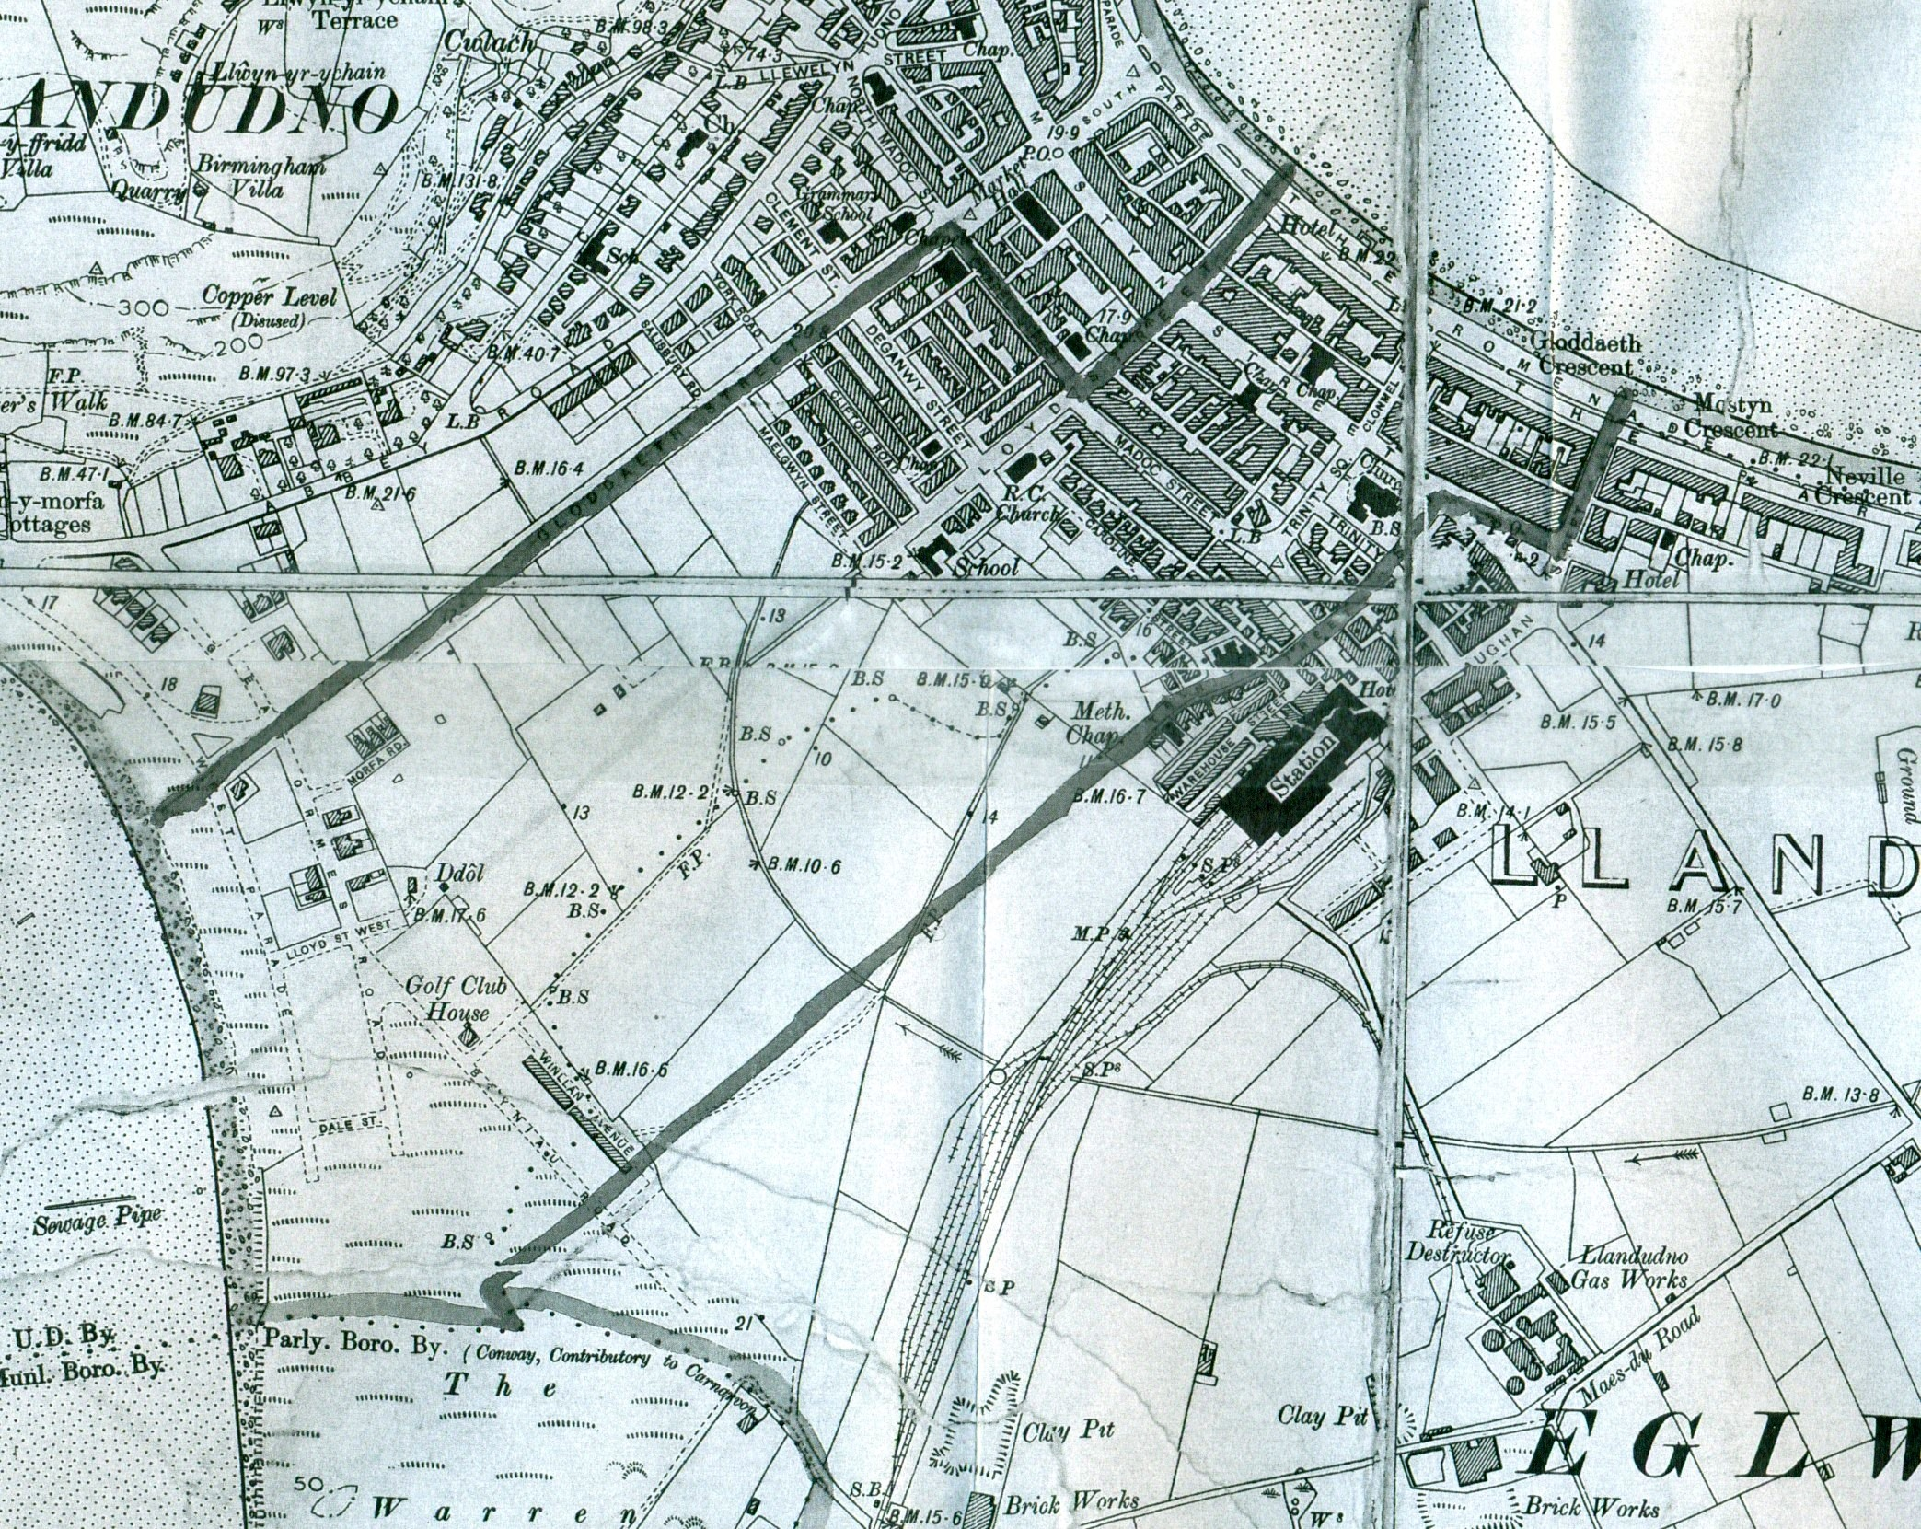
Parish Boundary between
Llandudno & Eglwys Rhos Parishes.
BS Boundary Stone
Figure 1

